**FUTURE ENHANCEMENT**

**Create a Flow to assign operations ticket to Group:**

|  |  |
| --- | --- |
| Date | **25 June 2025** |
| Team ID | **LTVIP2025TMID29036** |
| Project Name | **Streamlining Ticket Assignment for Efficient Support Operations** |
| Maximum Marks | **5 Marks** |

1. Open service now.
2. Click on All  >> search for Flow designer.
3. Click on Flow designer uner Process Automation.
4. After opening flow designer click on New and select Flow.
5. Under Flow properties Give Flow names as “Regarding certificate”.
6. Application should be Global.
7. Select Run user as “System user” from that choice.
8. Click on Submit.

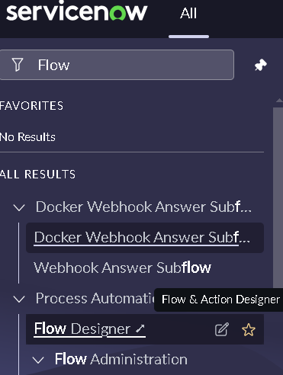

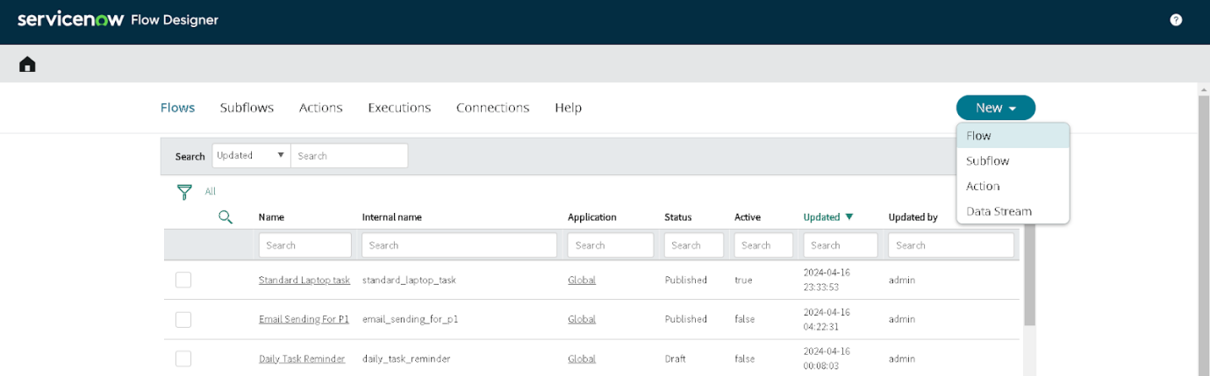

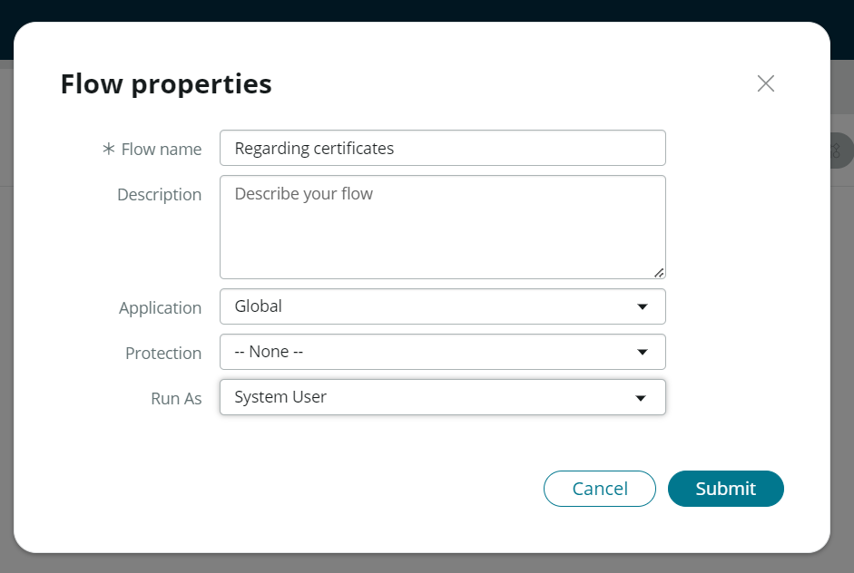

1. Click on Add a trigger
2. Select the trigger in that search for “create or update a record” and select that
3. Give the table name as ”Operations related”
4. Give the condition as

Field: issue

Operator: is

Value:Regarding Certificates

1. After that click on Done.

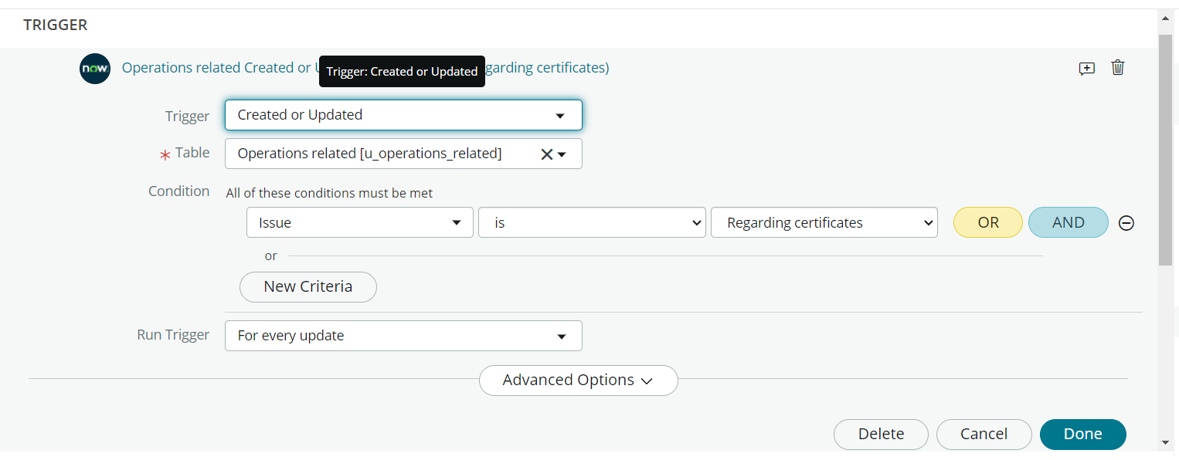

1. Now under Actions
2. Click on Add an action
3. Select action in that search for “Update Record”.
4. In Record field drag the fields from the data navigation from left side.
5. Table will be auto assigned after that
6. Give the field as “Assigned to group”
7. Give value as “Certificates”.
8. Click on Done.
9. Click on save to save the Flow
10. Click on Activate.

